**Difference between java Vs Javaw Vs Javaws**

|  |  |  |
| --- | --- | --- |
| Java( with console output) | Javaw**( without console output)** | Javaws( java web start) |
| Used to run java application and if any SOP statement is there in the application then it will execute it and the corresponding output will be displayed on the console. | Used to run java application and if any SOP statement is there in the application then it will execute but the corresponding output will be not be displayed on the console.  This command can be used in GUI based application. | Used to run java application, with this command we can run the java application using web url.  Systax : javaws <url> |
| **Import java.io.\***  **Class test{**  **Public static void main(String[] args);{**  **System.out.println(“ConsoleOutput”);**  **PrintWriter pw = new PrintWriter(“abc.txt”);**  **pw.println(“file Output”);**  **ps.flush(); // recommended after writing**  **}**  **}**  // Output in console is: **ConsoleOutput**  //One text will with name of abc.txt will be created with content will be **file Output** | **Import java.io.\***  **Class test{**  **Public static void main(String[] args);{**  **System.out.println(“ConsoleOutput”);**  **PrintWriter pw = new PrintWriter(“abc.txt”);**  **pw.println(“file Output”);**  **ps.flush(); // recommended after writing**  **}**  **}**  // No Output in console:  //One text will with name of abc.txt will be created with content will be **file Output** | As soon as we run this command, the whole application will start downloaded in the local (client) machine and start executing line by line. The advantages of this command is the main application can be executed from an ywhere i.e centralized control of the application. |

**Difference between JDK ,JRE and JVM**

|  |  |  |
| --- | --- | --- |
| **JDK** | **JRE** | **JVM** |
| 1-Provide the environment to develop and run the java application  2- Installed on developer’s machine to develop and run the program | 1-Provide the only environment to run the java application.  2- installed on client machine to run the application only | 1-JVM is responsible to run our java program.  2- It is an interpreter which read and executes each and every line of java (.class file) one by one |

JDK

1. JDK = JRE+ Development Tools
2. JRE = JVM + Library classes

**Coding standards in java**

**Coding standards for Classes:**

* Every class names whether it is predefined or our own defined represents one of the sever English part of speech NOUN.
* If class name contains multiple words then first later of each word would be in capital letter.
* Example (String , StringBugger , Dog…ect)

**Coding standards for Interfaces:**

* Every Interface names whether it is predefined or our own defined represents one of the seven English parts of speech Adjective.
* If Interface name contains multiple words then, first later of each word would be in capital letter.
* Example (Runnable , Serializable , Comparable …ect)

**Coding standards for methods:**

* Each method name represents some function or actions so methods name is nothing but represents the one of the seven English parts of speech verb. Example (println() , sleep() , run() ,eat() ,start().
* The first letter of method name should be in small letter . If method name contains multiple word then it should be in camel case . i.e first letter should be in small letter and every letter of inner word should be in capital case.
* Example : getName() , getEmpName() …etc

**Coding standards for variables:**

* Every variable names whether it is predefined or our own defined represents one of the seven English parts of speech NOUN.
* If variable name contains multiple words then, first later of each word would be in small letter and each of first letter of inner word would be in capital letter i.e it would be in camel case.
* Example (name ,salary , mobilNum …ect)

**Coding standards for constants:**

* Every constants name is very similar to variable names whether it is predefined or our own defined represents one of the seven English parts of speech NOUN. But to only difference is that constants values are fixed while variable values are vary.
* The whole word of constants should be in capital case. If contains multiple word then every word should be separated with (_) underscore.
* Example (MAX_VALUE , MIN_VALUE …ect)

**Modifies in java: There are 12 modifiers in java.**

|  |  |  |  |  |  |  |  |  |  |  |
| --- | --- | --- | --- | --- | --- | --- | --- | --- | --- | --- |
| **Modifies** | Classes | | Interfaces | | Methods | Variables | Blocks | Enum | | Constructor |
|  | outer | inner | outer | inner |  |  |  | outer | inner |  |
|  |  |  |  |  |  |  |  |  |  |  |
| Public | A | A | A | A | A | A |  | A | A | A |
| Private |  | A |  | A | A | A |  |  | A | A |
| Protected |  | A |  | A | A | A |  |  | A | A |
| <default> | A | A | A | A | A | A |  | A | A | A |
| Final | A | A |  |  | A | A |  |  |  |  |
| Abstract | A | A | A | A | A |  |  |  |  |  |
| Static |  | A |  | A | A | A | A |  | A |  |
| Synchronized |  |  |  |  | A |  | A |  |  |  |
| Native |  |  |  |  | A |  |  |  |  |  |
| Strictfp | A | A | A | A | A |  |  | A | A |  |
| Transient |  |  |  |  | A | A |  |  |  |  |
| volatile |  |  |  |  |  | A |  |  |  |  |
|  | 5 | 8 | 4 | 7 | 10 | 8 | 2 | 3 | 6 | 4 |

Enum: it is similar to class but every Enum by default is final so abstract is not allowed

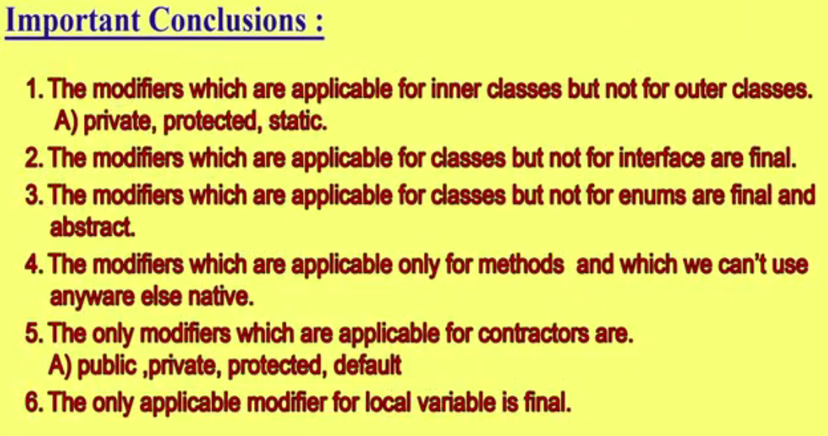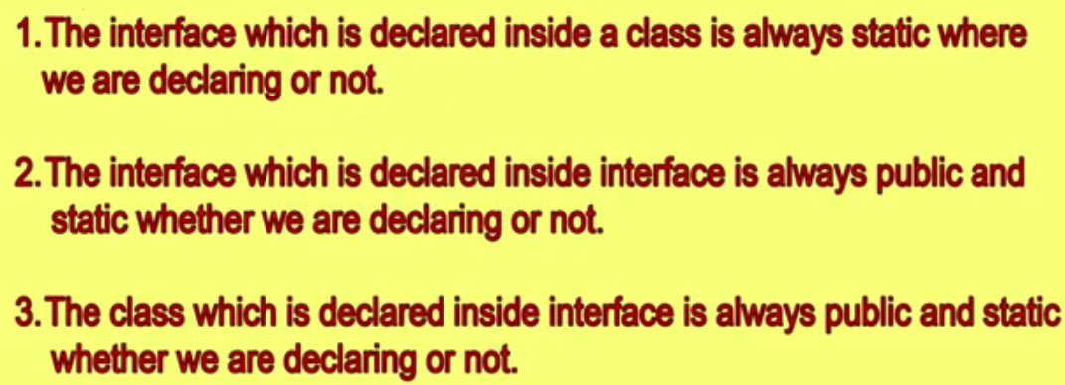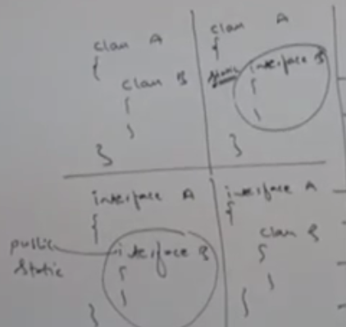

**Difference between Access Specifiers Vs Access Modifiers**

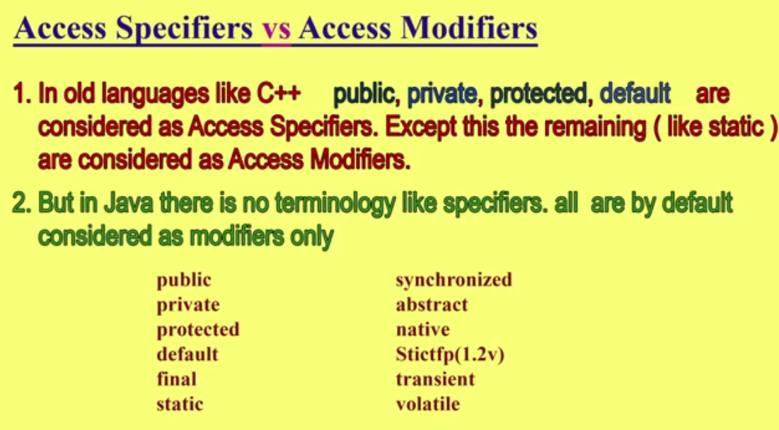

**Proof with practical**

Example: Let’s take an outer or top level class test. Since in an outer class the only applicable modifiers are (public, default, final, abstract and strictfp). Now except these if we apply others like (private) then immediately we will compile time error saying (CE: **Modifiers** private not allowed here) . Hence we can see that compiler itself by default return modifier not Specifiers in java. Hence in java there is no any concept of **Specifiers**

**private class test**

**{**

**.**

**.**

**}**

**// CE: modifiers are not allowed here**

**Complete Architecture of JVM**

* **Virtual Machine**
* **Type of virtual Machine**

1. **Hardware based virtual machine**
2. **Software based virtual machine**

* **Basic Architecture of JVM**
* **Class Loader Subsystem**

1. **Loading**
2. **Linking**
3. **Initialization**

* **Types of Class Loaders**

1. **Bootstrap Class Loaders**
2. **Extension Class Loaders**
3. **Application Class Loaders**

* **How Class Loader Works.**
* **What is the need of Customized Class Loader?**
* **Pseudo Code for customized Class Loader.**
* **Various Memory Areas of JVM**

1. **Method Area**
2. **Heap Area**
3. **Stack Area**
4. **PC Registers**
5. **Native Method Stacks**

* **Program to display heap memory statistics**
* **How to set Maximum and Minimum heap size?**
* **Java Native Interface (JNI)**
* **Execution Engine**

1. **Interpreter**
2. **JIT Compiler**

* **Complete Architecture Diagram of JVM**
* **Class File Structure.**

**Virtual Machine (VM):**

1. The meaning of virtual is , which is not original , not physical
2. A software simulation of machine which can perform operation like a physical machine like Calculator. Such type of machine is called VM

**Type of virtual Machine**

1. **Hardware based / System Based**
2. **Application based / process Based**

**Hardware based / System Based VM**

It provides several logical system on the same computer with strong isolatation from each other i.e. on one physical machine we are defining multiple logical machines.

The main advantage of H/W base VM is hardware resources sharing and improves utilizations of H/W resources.

Ex. KVM (Kernel Based VM for Linux system), VMware, Cloud Computing etc. Hardware based VM is done by Server Admin

**Application Based / Process Based**

These VM access run time engines to run particular programming language applications.

JVM (Java virtual Machine): It access run time engine to run java based applications

PVM (Perl VM): It access run time engine to run perl based application (scripting language).

CLR (Common Language Runtime): It access run time engine to run .net based applications

JVM: It is the part of JRE and it is responsible to load and run java (.class) files

**Basic Architecture diagram of JVM:**

Class Loader Subsystem

Stacks Area

Heap Area

Method Area

**Operating System**

Native Method Libraries

Java Native Interfaces

JIT Compiler

Interpreter

Execution Engine

**Native Method Stacks**

.class files

Various Memory Area which allocates at run time

PC Registers

**JVM Module 1:- Class Loader Subsystem:**

It is responsible for the following three activities

1. Loading of the .class file
2. Linking of .class file
3. Initialization of .class

**(1)Loading of the .class file:**  Loading means reading class files (class codes) and store corresponding binary data in method area. For each class file JVM will store corresponding information in the JVM **method area.**

1. Fully qualified name of class
2. Fully qualified name of immediate parent class

The whole .class file code (binary data) will be stored by default in JVM method area only

1. Methods information

.class files stored in hard disc

1. Variables information
2. Constructions information
3. Modifiers Information
4. Constant pool information

After loading .class file, immediately jvm creates an object for that loaded class on the heap memory of type java.lang.Class

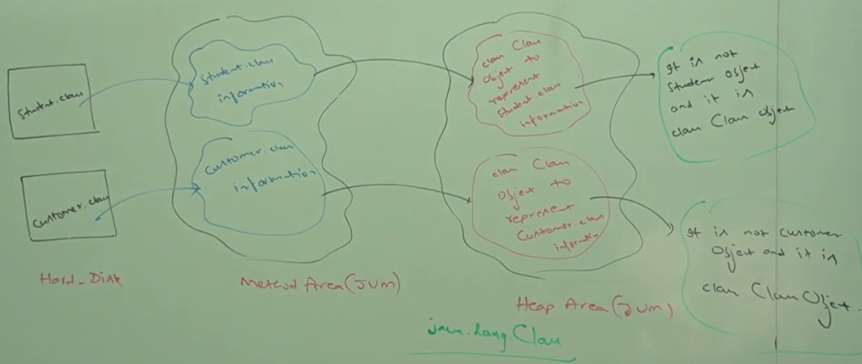

As we can see in the above image that we have two .class file (Student. class and Customer. class) stored in our hard disk after compilation. These class files gets loaded in Method area of JVM and after loading .class file, immediately jvm creates an object for that loaded class on the heap memory of type java.lang.Class.

These objects will of java.lang.Class class type not for student or customer class object.

Till now we can see that three memory areas are involved (hard disc, Method area, Heap Area)

The class Class object can be used by programmer to get class level information like method information, variable information, construction information, constants information written in class.

|  |  |
| --- | --- |
|  |  |

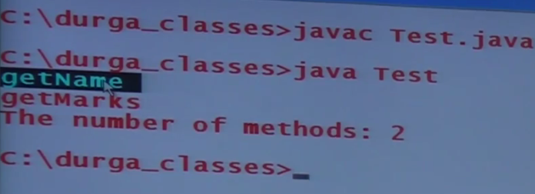 Output

In the above example (java.lang.reflect.*) is used for class (Class and Method)

Class c = Class.forName (“Student”); // this is used to load the class Student in Method Area and heap area

Method [] m = c.getDeclaredMethod (); // Will give the all declared method in the class Student

Class c = Class.forName (“java.lang.String”); //// this is used to load the class String

So when we run above program.

Note: For every loaded type only one class object will be created even though we are using the class multiple times in our program.

|  |  |
| --- | --- |
|  |  |

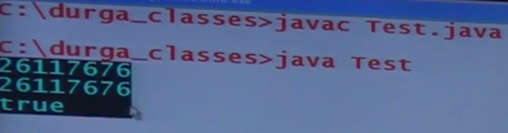

As in the above example we can see that when we are using Student class, it got loaded in method area and immediately one object of class Class type gets created.

Now if we create object of student class multiple time, even though it will point the same class object. It means the loading and creation of class Class object happens only once.

**(2) Linking of .class files**

It consists of three activities

1. Verify or byte code verifications
2. Prepare
3. Resolve or Resolution.

**Verify** It is the process of insuring that binary representation of a .class file is structurally correct or not i.e. jvm will check whether the .class file generated by valid compiler or not .i.e. whether .class is properly formatted or not. Internally byte code verifier is responsible for this activity. Byte code verifier is the part of class loader subsystem.

If verifications fail then we will get run time exception saying **java.lang.verify error**.

**Preparation:**  In this phase JVM will allocate memory for class level static variables and assign their default values.

Note: In initialization phase original values will be assigned to the static variables and here in preparation only default values will be assigned.

**Resolve or Resolution:** In this phase replacing symbolic name in our programs with original memory references from method area are done.

|  |  |
| --- | --- |
| Class Test  {  Private static void main (String [] args)  {  String s = new String (“Arun”);  String s1 = new Student ();  }  } | 1. For this class class loader loads , Test.class , String.class , Student.class and Object.class 2. The names of these classes are stored in constant pool of Test class. 3. In resolution phase these names are replaced with original memory level references from method area. |

**(3) Initialization** In this all static variables are assigned with original values and static blocks will be executed from parent to child and from top to bottom.

Prepare

**Class Loading Subsystem / Process**

Verify

**Initialization**

**Loading**

Resolve

Note: While loading, linking and initialization if any error occurs then we will get run time exception saying java.lang.Linkage Error. **Java.lang.verify error is the child class of** saying java.lang.Linkage Error .That is why we will get java.lang.Linkage Error in all the phase if any error occurs.

**Class Loader Subsystem and Types of class Loaders (Delegation hierarchy algo)**

Class loader subsystem contains the following three types of class loader

1. Bootstrap class loader or primordial class loader
2. Extentation class loader or
3. Application class loader or system class loader

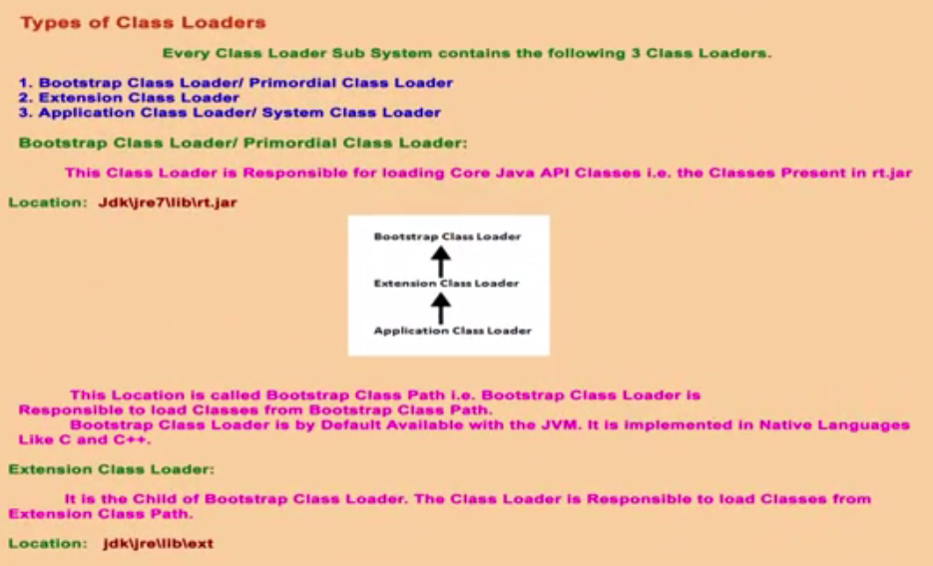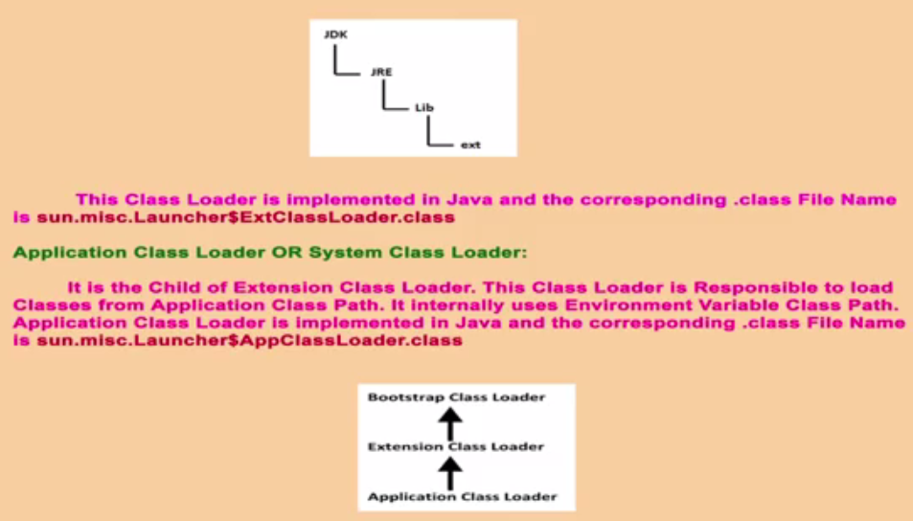

**Bootstrap Class loader :** rt.jar contains all the core java related API classes ,interfaces methods etc like String , StringBuilder ….etc and this jar is located inside( jdk-🡪 jre -🡪 lib -🡪 rt.jar) and bootstrap class loader is responsible to load these core java related classes and interfaces from rt.jar.

Bootstrap Class loader by default present in JVM but bootstrap class loader is not implemented in java. It is implemented in native languages(C and C++)

**Extentation Class Loader:**

1. It is the child of bootstrap class loader.
2. It is responsible to load the classes from extentation path (jdk-🡪 jre -🡪 lib -🡪 ext-🡪 (list of .jar files) . In other words this class loader loads all the API classes and interfaces from .jar present inside ext folder.
3. This class loader is implemented in java only and one example of the class loader is (sun.misc.Launcher$ExtClassLoader.class). Here ($) represents that ExtClassLoader is the inner class of Launcher class.

**Application Class Loader:**

1. It is the child of extenuation class loader.
2. This class loader is responsible to load the classes from application level path. i.e this class loader loads all the classes from the application i.e all class presents inside the application (user defined classes) is loaded by Application class loader.
3. This class loader is implemented in java and the corresponding Application class loader class name is (sun.misc.Launcher$AppClassLoader.class) , where AppClassLoader class is the inner class present inside Launcher class.

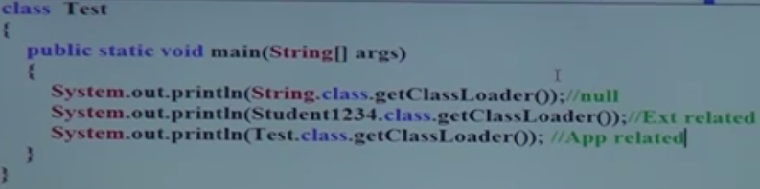

After run this class

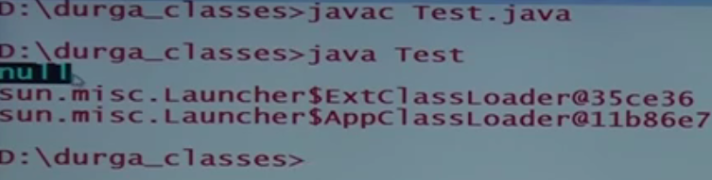

**Note1-:**  As we can see in the above example first SOP represents the bootstrap class loader class and when this line gets executed, output will be null because this class is written in native language

**Note2-**The second SOP , here we created one java file with name of Student123.java and convert this in jar and put inside the ext folder so the second SOP represents extentation class loader and when this executes , output will be (sun.misc.Launcher$ExtClassLoader.class) .

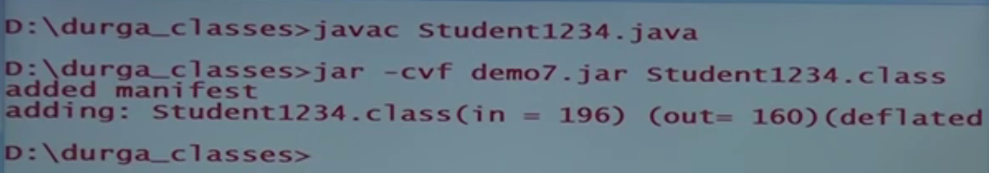

1. First of all compile the Student1234.java using javac Student1234.java
2. Convert this in demo7.jar using (jar –cvf demo7.jar Student1234.class)
3. Place demo7.jar inside (jdk-🡪 jre -🡪 lib -🡪 ext folder-🡪demo7.jar)

**Note3-**The third SOP, here we create on java file with name Test.java and put in our present directory i.e. application level folder so the third SOP represents application class loader and when executes, output will be (sun.misc.Launcher$AppClassLoader.class).

**How class Loader algorithm (Delegates algo) Works**

Class loader fallows delegation hierarchy principals. When JVM come across a particular (test. Class), first it will check whether the corresponding file is already loaded or not if it is already loaded in method area then JVM will consider that loaded class file , If it is not loaded then JVM requests class loader subsystem to load that particular class (test. class) then class loader subsystem handover request to Application class loader . Application class loader delegates request to extentation class loader ,which intern delegates request to Bootstrap class loader ,then bootstrap class loader will search the particular .class file in bootstrap path , if it available then the corresponding .class will be loaded by BS class loader , if it is not available then BS class loader delegates request to extentation class loader. EX class loader will search that particular class (test.class) in Ex Class path. If it is available then it will be loaded otherwise Ex . Class loader delegates the request to Application CL. Now Application CL will search that particular class (test.class) in application class path. If it is available then it will be loaded otherwise we will get run time exception saying ClassNotFound exception or NoClassDefFoundError

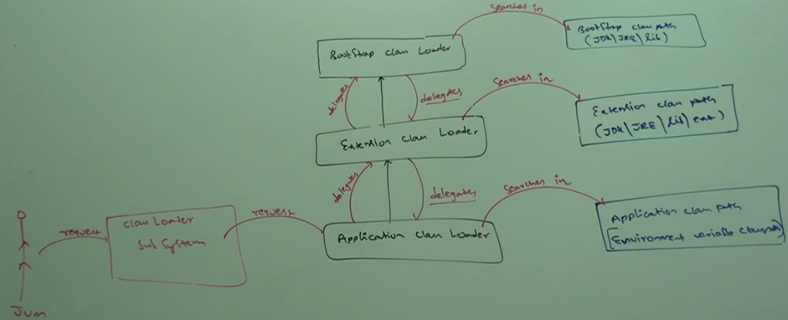

Note1-: BS CL is not java object hence we got Null in the first case but extentation and application class loader are java objects and hence we are getting corresponding output for the remaining two SOP. [classname @hashcode in hexadecimal form]

Note2- : Class loader subsystem will give the highest priority for Bootstrap class path and then Extentation class path fallowed by application class path.

**Need of Customized class loader**

Default .class file will load .class file only once even though we are using multiple times that class in our program.

After loading .class file if it is modified outside then default class loader would not load updated version of class file (because .class file is already available in method area)

We can resolve this problem by defining our own customized class loader. The main advantages of customized class loader are we can control class loading mechanism based on our requirements.

For example, we can load .class file separately every time so that updated version available to our program.

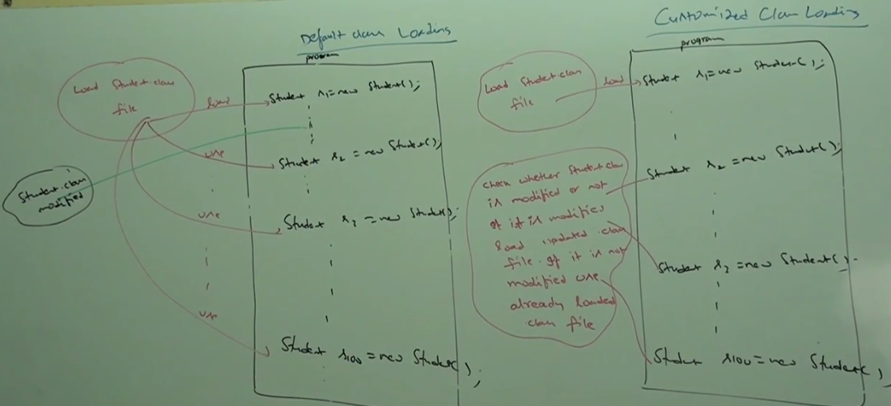

**How to define our own customized class loader(Pseudo Program)**

We can define our own customized class loader by extending java.lang.ClassLoader class.

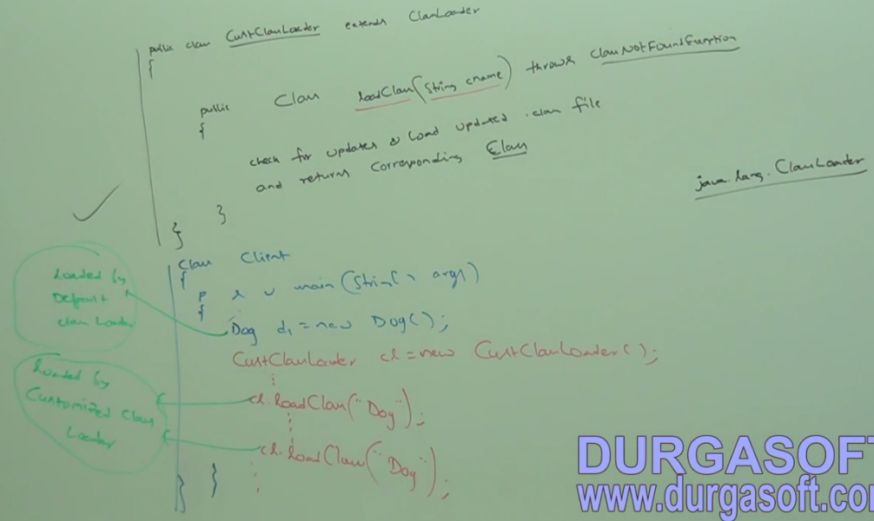

Note: While developing web server and applications servers usually we can go for customized class loaders to customize class loading mechanism.

**Q:- What is the need or use of ClassLoader class?**

We can use java.lang.ClassLoader class to define our own customized class loaders. Every class loader in java should be child class of java.lang.ClassLoader class either directly or indirectly. Hence this class access base class for all customized class loaders.

Object Data 

Object Data

Object Data 

Class lever Data

Class lever Data

Class lever Data

**Module 2 of JVM : Various memory Areas present inside JVM**

Whenever JVM loads and run a java program it needs memory to store several things like byte codes, objects, variable etc

Total JVM memory organized into fallowing 5 categories.

1. Method Area
2. Heap Area
3. Stack Area
4. PC Registers
5. Native Method stacks

**METHOD AREA OF JVM**

1. For Every JVM one method area will be available.
2. Method area will be created at the time of JVM startup.
3. Inside method area class level binary data including static variable will be stored.
4. Constants pools of a class will be stored inside method area.
5. Method Area can be accessed by multiple threads simultaneously so it is not thread safe.

Method Area need not to be contagious as shown in the below diagram.

**HEAP AREA OF JVM**

1. For every JVM one heap is available.
2. Heap Area will be created at the time of JVM startup.
3. Objects and corresponding instance variables will be stored in the Heap Area.
4. Every array in java is object only hence Arrays also will be stored in the Heap Area.
5. Heap area can be accessed by multiple threads and hence the data stored in the heap memory is not thread safe.
6. Heap Area need not be continuous i.e. it is in distributed form.

**Program to display heap memory statistics**

1. A java application can communicate with JVM by using run time object.
2. RunTime is singleton class which is present in java.lang package. We can create run time object as fallows

RunTime RT = RunTime.getRunTime ();

1. Once we got run time object we can call the fallowing methods on that object.

* **MaxMemory:** It returns number of bytes of max memory allocated to heap.
* **TotalMemory or initialMemory:** It returns number of bytes of total memory allocated to the heap.
* **FreeMemory:** It returns number of bytes of Free memory present in the heap

|  |  |
| --- | --- |
|  |  |
|  |  |

|  |  |
| --- | --- |
|  |  |
| 1. The first output is in bytes 2. Second output is in MB 3. Third output is also in MB but in exact value. | |

**How to set Minimum and Maximum Heap Sizes**

1. Heap Memory is fixed or finite memory but based on our requirement we can set maximum and minimum heap sizes i.e. we can increase or decrease heap size based on our requirements.
2. We can use the fallowing flags with java commands
3. -**Xmx :** This command is used to set maximum heap size(In this case MaxMemory() method is going to be impacted)

Java -Xmx512m HeapDemo

This command will set maximum heap size as 512 MB

1. -**Xms :** This command is used to set minimum heap size(in this caseTotalMemory() method is going to be impacted )

Java -Xms64m HeapDemo

This command will set minimum heap size as 64 MB

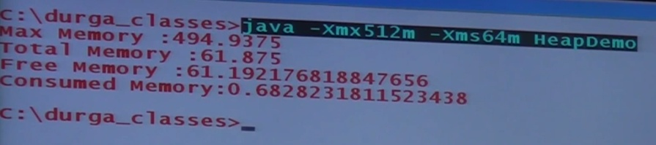

 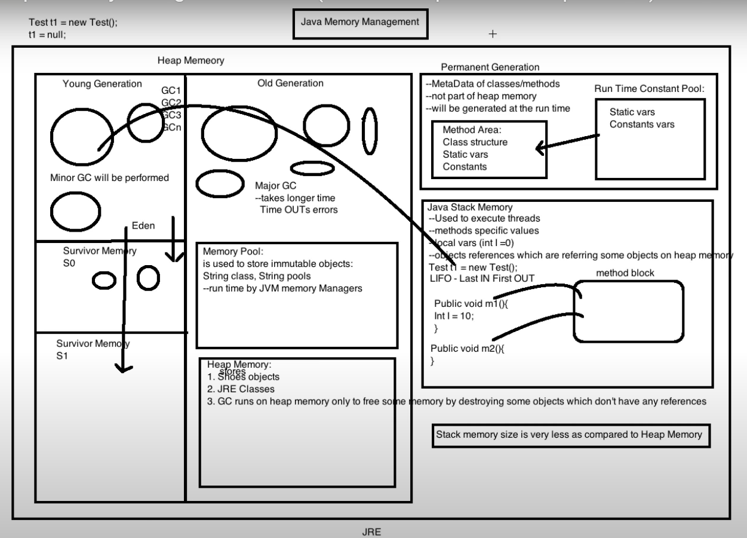

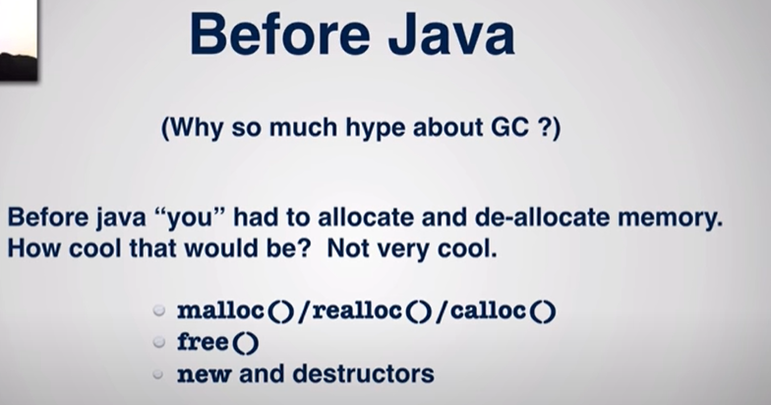

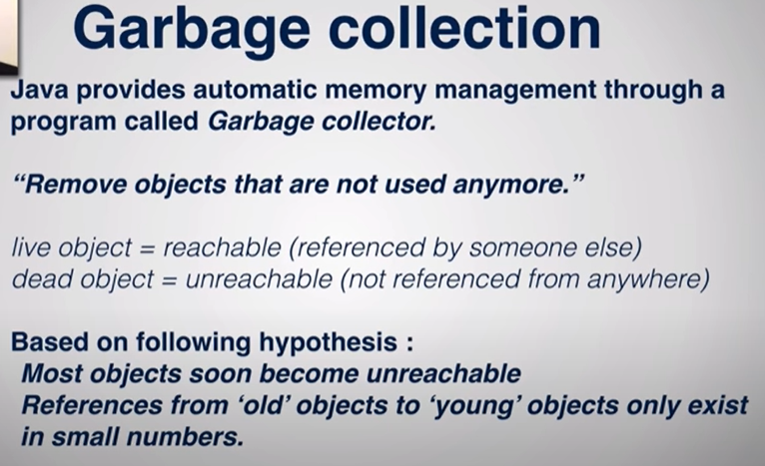

Steps:

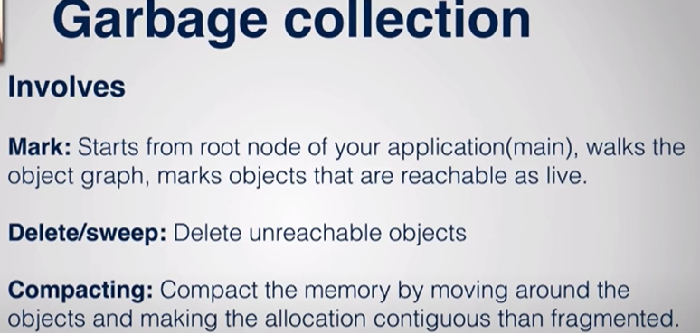

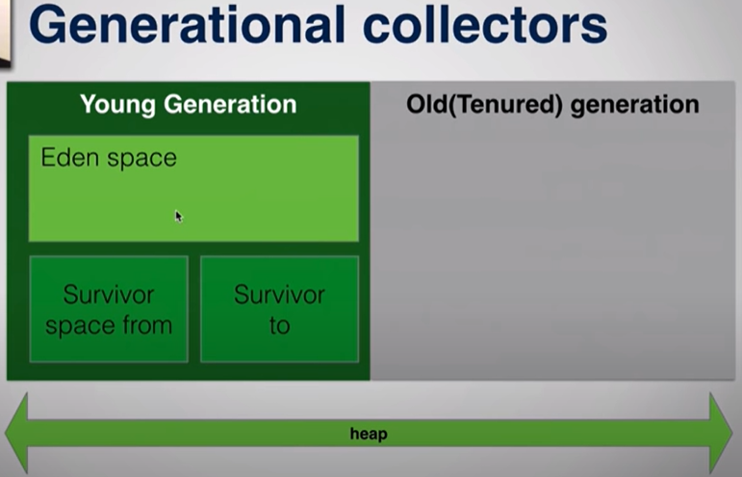

|  |  |
| --- | --- |
| When Eden is full then Minor GC perform marking the reachable & untenable object    Unreachabl object will be sweepedup from eden space | Move all reachable object into survivor 1 |
|  | Obj mved from Sur1 to sur2 and here JVM will check that object are suriving 1 to 3 cycle and based on this surviver cycle until it reachesh to threshold and after that it move these object to old generation space |
|  | Now if Old generation also full after some time the major GC comes into picture and it goes through out the Heap area and then mark , sweep and compact activity. When this activity happens it takes lot of time |

|  |  |
| --- | --- |
|  |  |

|  |  |
| --- | --- |
|  |  |

|  |  |
| --- | --- |
| Run the above command on CMD |  |

**final Keyword:**

|  |  |
| --- | --- |
|  | Final keyword can be used with variable, method, class. |

Final variable:

1. As we know that the instance variable varies from object to object. But if use final with instance variable then it is treated as constant.
2. For instance variable we are not required to perform initialization explicitly, JVM will always provide default values if we don’t initialize instance variable at the time of declaring.
3. If the instance variable declared as final then compulsory we have to perform initialization explicitly whether we are using or not and JVM won’t provide default values.

|  |  |  |
| --- | --- | --- |
| Class test{  Int x;  Static Int y;  P s v main (String[] args) {  Test t = new Test();  Sopln(t.x); Sopln(t.y);  }  Output: 0 for x and y both (default value of the integer) | **Final variable is not initialized at declaration time**  Class test{  final Int x;  P s v main (String[] args) {  Test t = new Test();  Sopln(t.x);  }  CE: Variable x must be initialized | **At the time of variable declaration.**  Class test{  final Int x=10;  P s v main (String[] args) {  Test t = new Test();  Sopln(t.x);  }  Output: 10 |
| **Inside the instance block.**  Class test{  final Int x;  {  X=10  }  Output: 10 | **Inside constructor:**  Class test{  final Int x;  test() {  X=10  }  Output:10 | **Do not initialize inside method.**  Class test{  final Int x;  final static Int y;  public void(){  x=10; y=20;  }  CE: cannot assign final Variable x & y inside method, because method will be executed after constructor. |

Rule1-: For finale variable compulsory perform initialization before constructor completion.

Rule2-: Finale variable can be initialized inside the instance block

Rule3-: Final variable can be initialized inside the constructor

These are the only places to perform initialization for final variable. If we are trying to perform initialization anywhere else then we will get compile time error.

Note: if the value of variable is not going to change object to object then never declare the variable as an instance variable because it will waste unnecessary memory and decrease the performance. For example the College name for all the student is not going to change. Such type of variable should be declared as static at the class level. And hence only once copy will be created in the memory and shared by the entire object of the class. For static variable the default value is going to provide by JVM, we are not required to perform static variable initialization explicitly.

Order of modifier is not important:

Static final int x=0 or final static x =0 both are same.

Q: But if static variable is final then what will happen?

So compulsory we must perform initialization explicitly, otherwise compile time error we will get and JVM would not provide any default values. And three rules final static variable.

Rule1-: For finale variable compulsory perform initialization at the time declaration before class load completion i.e. before main () loading.

Rule2-: Finale variable can be initialized inside the static block.

Apart from these two places if we perform initialization anywhere else then we will get compile time exception.

|  |  |  |
| --- | --- | --- |
| **Do not initialize inside method.**  Class test{  final Int x;  final static Int y;  public void(){  x=10; y=20;  }  CE: cannot assign final Variable x & y inside method, because method will be executed after constructor | **Inside the static block.**  Class test{  final Int x;  static{  X=10;  }  Output: 10 | **At the class level before main () method gets loaded.**  Class test{  Final static Int x=10;  P s v main (String[] args) {  Test t = new Test();  Sopln(t.x);  }  Output: 10 |

How the HashMap work internally?

|  |  |
| --- | --- |
| **package** com.employee.salary;  **import** java.util.HashMap;  **import** java.util.Map;  **public** **class** HashSetInternalWorking {  **public** **static** **void** main(String[] args) {  Map<String, Integer> hsMarks = **new** HashMap<String, Integer>();  hsMarks.put("Naveen", 100);  hsMarks.put("Tom", 200);  hsMarks.put("Lisa", 300);  hsMarks.put("Peter", 400);  hsMarks.put("Ruby", 600);  hsMarks.put(**null**, 100);  hsMarks.put(**null**, 100);  hsMarks.put("Naveen", 900);  }  } |  |

1. As here in the above program we have created one HashMap<String, Integer> and using this HashMap object we are inserting name as string and marks in integer.
2. Since in HashMap null key and duplicate is allowed that is why we have created two null entries and two duplicate entries.
3. HashMap is data structure which stores the data in the form of key-value pair. HashMap work on basis if hashing. Java using one method called hasCode() which belongs to Object class. Let’s understand how the HashMap works.
4. The moment we create HashMap it creates 16 nodes (0-15) or bucket by default. The default value of the HashMap is 16.
5. Each node or bucket will maintain [hashCode, Key, Value, PointerOfNextNode].
6. Now on the basis of hashing concept java will start storing these values in the bucket. So very first time when we will make an entry like this [hsMarks.put ("Naveen", 100);] then first of all a hashCode will be calculated using the HashMap key [int hash= hashCode (Naveen)] and it will provide an integer number. Let’s say it gives an integer hashCode value (210687).
7. Now using this integer hashCode we will be calculating index using [int index= hash & (n-1)]. Here n is size of the HashMap ( like here initially the default size of HashMap is 16)

**Note: Q:** Why we can’t use this hashCode as an index because here these buckets is in the form of index array. Ans: The hashCode that we have got is so big in number and practically it is not possible to use as a because if we using this hashCode as an index then it will consume lot of memory and very soon we will be out of memory. That is why using this hashCode we calculate an index. Let’s say for the first entry [Naveen] we have got index =4

1. Now the first entry will be stored at index 4 in the form of **node[hashCode, Key, Value, PointerOfNextNode]**. If it does have any next node at index 4 then this means it is not pointing to any next node and in this case PointerOfNextNode will null. So the exact node will be look like [210687, Naveen, 100, null]
2. Similarly let’s assume for the next entry [hsMarks.put("Tom", 200);] the hashCode is 210780 and the index is 9 then this entry will be stored at index 9 in the form of **node[**210780**, Tom, 200, null]**.
3. Now let’s assume one case where two entry has got same hashCode, then in this case the index number also will be same and hence that entry then will be stored on the same index and in this case at one index we will have two entry or node and then in this case **PointerOfNextNode** will not be null and instead of null this node will point the address of next node. Let’s assume for entry [hsMarks.put("Lisa", 300);] we have got exactly same hashCode what we have got in case of first entry means hashCode= 210687 and index is 4 then in this case this record will be stored at index 4 and in this case the both the node will look like as [210687, Naveen, 100, **PointerOfNextNode**] 🡪 [210687, Lisa, 300, **null**]. So in this case it behaves like linked list.
4. Similarly for the remaining entries the hashCode will be calculated using key and further using hashCode index will be calculated and then entries will be stored at the same index. Sometime it could be possible that we will get different hashCode but will get same index then in that case entry will be stored at the same index next to the already available entry in the form of linked –list.

Note: When several entries are stored at the same index then this condition is called collision

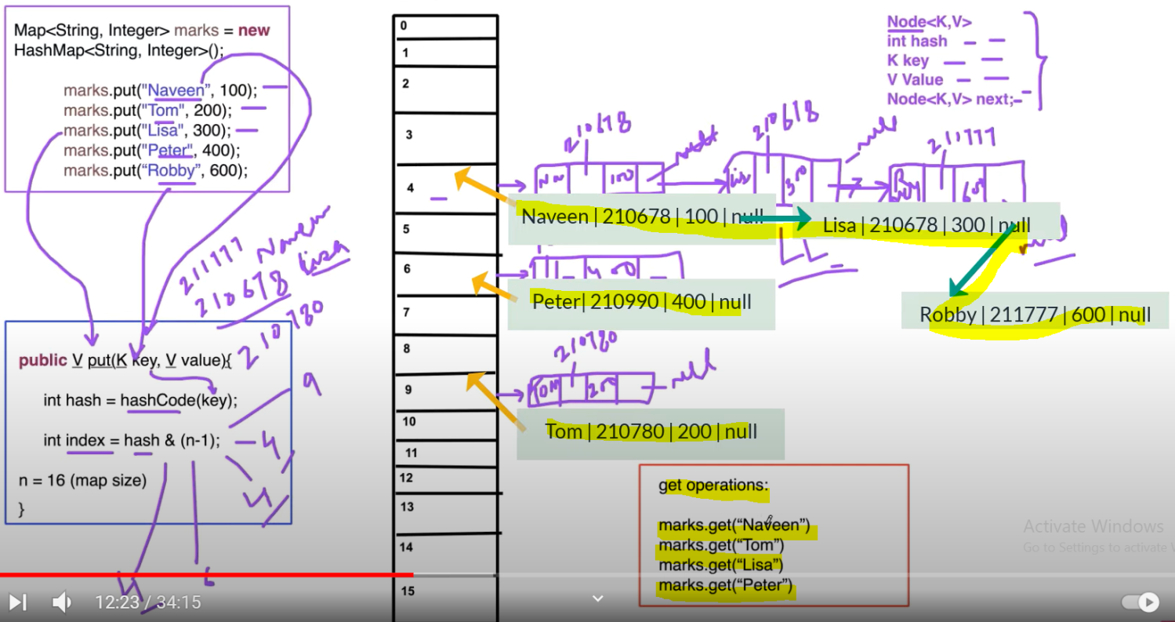

**Let’s talk about null key and duplicate key:**

|  |  |
| --- | --- |
| hsMarks.put(**null**, 100);  hsMarks.put(**null**, 100); | In case of Null key the calculated hashCode always will be zero (0) and then index also will be zero and hence in case of null the entry always will be stored at zeroth index in HashMap and the entry will like **node[hashCode, Key, Value, PointerOfNextNode]**🡨🡪 **node[**0**, null, 200, null]**. |
| hsMarks.put("Naveen", 900); | In case of duplicate key again the hashCode and index will be same and then in this case the old value will be replaced with new value for the duplicate key |

**Let’s talk about fetching value from HashMap**. Since we know that in case of HashMap the value will be fetched by Key. So it works internally?

Let’s say we are trying to fetch hsMarks.get("Naveen");

In this case also first of all the hashCode will be calculated by using key and then further using that hashCode, index will be calculated, let’s say we have got hashCode= 210678 and index = 4 . Now it will go to index four and here it will found three nodes. So first it will go first node and check whether we have the same hashCode using **equals () method** of Object class. If hashCode got matched then it will search for the same key and if key matched with the same hashCode then the corresponding value will be fetched. Like here in case of Naveen key 100 as value will be fetched. Similarly in case of Lisa we will get same hashCode and index, so in this case now it will go to index 4 and first it will check the first node and here it will found that hashCode is same but key is not matched so now it will move to the next available node and again check and compare using equal () method and now here it will found the Key Lisa at the same hashCode and then in this case value 300 against Lisa Key will be fetched. So this how get operation works.

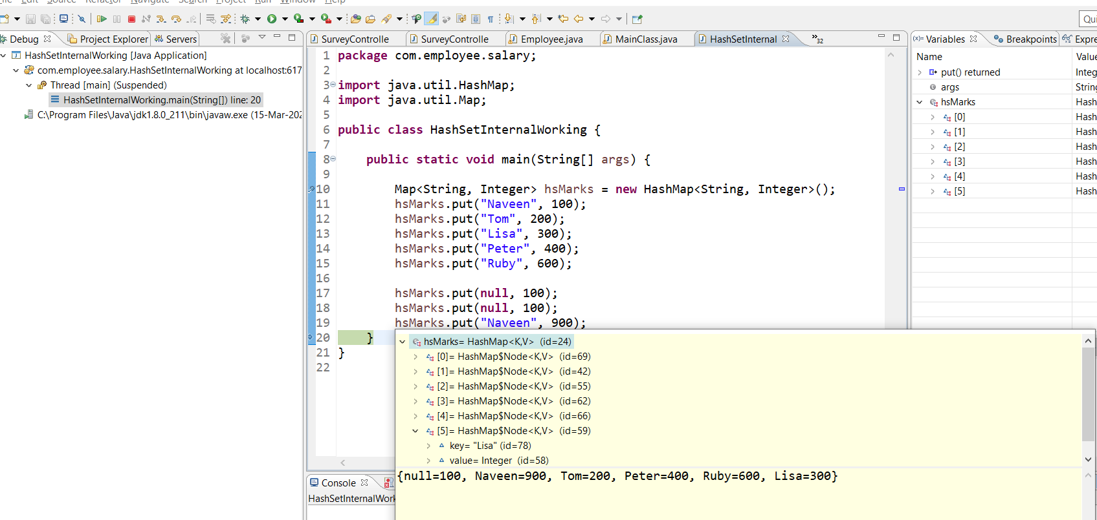

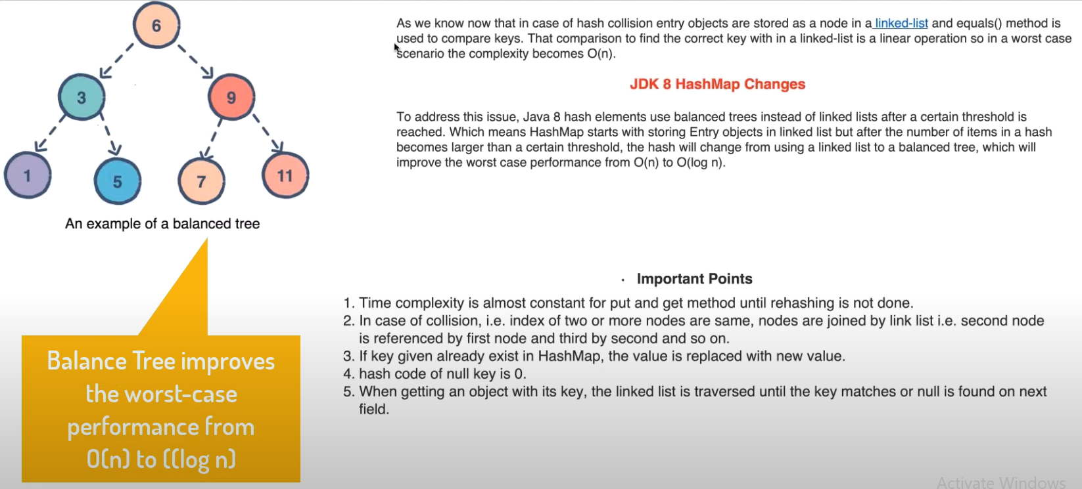

It means if the nodes having same hashCode keep adding at the same index and let’s say it reaches to its threshold then this case the linear linked-list will be automatically converted into balanced tree to improve the performance.

The performance of Linked-list is O(n) and for balanced tree O(log n)

Note: As we know that the initial size or capacity of HashMap is 16 (0-15). And its factor value is .75. It means once the 75% (threshold value) HashMap gets occupied then the value of the HashMap will be double in the size. The threshold value will be calculated as 16x.75= 12 means once the entry reaches to 12 index then HashMap size will become double.

**How HashSet works Internally? Do you know HashSet uses HashMap Internally? (Java Collection)**

<http://www.docjar.com/html/api/java/util/HashSet.java.html>

Steam pipeline

As we already know that HashMap internally uses and index mechanism for storing HashMap data. Here HashMap key plays a very important role because using Key only hashCode gets calculated and then using this hashCode index get calculated and then according to index we place [hashCode, Key, Value, PointerToNextNode] in the form of node.

Now in case of HashSet as the name indicates that it also store the data based on HashCode only. HashCode internally uses HashMap mechanism for storing data into node or bucket.

Q: In case of HashMap have Key and value pair where key plays a very important role in calculating hashCode and index but in case of HashCode we have only value, then how these values are stored based on hashCode and how they use HashMap mechanism to store the data into node or bucket?

Answer:

public class HashSet<E> extends [AbstractSet](https://docs.oracle.com/en/java/javase/11/docs/api/java.base/java/util/AbstractSet.html)<E> implements [Set](https://docs.oracle.com/en/java/javase/11/docs/api/java.base/java/util/Set.html)<E>, [Cloneable](https://docs.oracle.com/en/java/javase/11/docs/api/java.base/java/lang/Cloneable.html), [Serializable](https://docs.oracle.com/en/java/javase/11/docs/api/java.base/java/io/Serializable.html)

This class implements the Set interface, backed by a hash table (actually a HashMap instance).it does not guarantee that the order will remain constant over time. This class permits the null element.

|  |  |
| --- | --- |
| **Constructor** | **Description** |
| [**HashSet**](https://docs.oracle.com/en/java/javase/11/docs/api/java.base/java/util/HashSet.html#%3Cinit%3E())() | Constructs a new, empty set; the backing HashMap instance has default initial capacity (16) and load factor (0.75). |
| [**HashSet**](https://docs.oracle.com/en/java/javase/11/docs/api/java.base/java/util/HashSet.html#%3Cinit%3E(int))​(int initialCapacity) | Constructs a new, empty set; the backing HashMap instance has the specified initial capacity and default load factor (0.75). |
| [**HashSet**](https://docs.oracle.com/en/java/javase/11/docs/api/java.base/java/util/HashSet.html#%3Cinit%3E(int,float))​(int initialCapacity, float loadFactor) | Constructs a new, empty set; the backing HashMap instance has the specified initial capacity and the specified load factor. |
| [**HashSet**](https://docs.oracle.com/en/java/javase/11/docs/api/java.base/java/util/HashSet.html#%3Cinit%3E(java.util.Collection))​([**Collection**](https://docs.oracle.com/en/java/javase/11/docs/api/java.base/java/util/Collection.html)<? extends [**E**](https://docs.oracle.com/en/java/javase/11/docs/api/java.base/java/util/HashSet.html)> c) | Constructs a new set containing the elements in the specified collection. |

So above as per the above detail we have four constructors in HashSet and every constructor is backed by HashMap i.e. internally each HashSet use HashMap. Let’s provide the internal detail of each constructor.

If we go inside HashSet class then we will see the above constructor is defined as below.

|  |  |
| --- | --- |
| public HashSet() {  map = new HashMap<>();  } | HashSet<String> hs = **new** HashSet<String>();  hs.add("Alpha");  hs.add("Beeta");  hs.add("Gama");  hs.add("Theeta");  **public boolean add(E e) {**  **return map.put(e, PRESENT)==null;**  **}** |
| public HashSet(Collection<? extends E> c) {  map = new HashMap<>(Math.max((int) (c.size()/.75f) + 1, 16));  addAll(c);  } |
| public HashSet(int initialCapacity, float loadFactor) {  map = new HashMap<>(initialCapacity, loadFactor);  } | **public boolean add(E Alpha) {**  **return map.put(“Alpha”, PRESENT)==null;**  **}** |
| public HashSet(int initialCapacity) {  map = new HashMap<>(initialCapacity);  } | So as per the below HashSet class here we have created reference of transient HashMap which is being initialized in each constructor accordingly. |
| **public boolean add(E e) {**  **return map.put(e, PRESENT)==null;**  **}**  **public boolean remove(Object o) {**  **return map.remove(o)==PRESENT;**  **}** | We have created on constant variable PRESENT, this constant variable is entered as value in the put method of HashMap as we can see the above the value of HashSet will be used as key here inside the constructor hashmap put method |

In other word when we use add() method of HashSet then internally in the add() method, HashMap put method is being defined and here inside put method value of HashSet will inserted as Key and PRESENT will be the value. So here inside HashMap put() method value always will be Constant PRESENT.

Now the remaining mechanism will be similar to HashMap mechanism.

The value of HashSet will inserted as key and then using this Key hasCode and index will be calcualated and then the value will be inserted according to calculated index. So in case of hasSet the node will be look like as.

Node[hashCode, Key, Value, PointerOfNextNode] ==

node[210012, Alpha, PRESENT, PointerOfNextNode] 🡨 🡪[210012, Beeta, PRESENT, null] (Alpha & Beeta have got same hashCode and same index so now they will be treaded as linked list.

node[2100226, Gama, PRESENT, null] node[210226, Theeta, PRESENT, null]

**Note**: In the HashSet we do not have any get () method unlike we have in HashMap and other collection. So we cannot fetch single value. If we want to fetch HashSet value then we can fetch entire HashSet value using Iterator cursor.

|  |  |
| --- | --- |
| public class HashSet<E> extends AbstractSet<E> implements Set<E>, Cloneable, java.io.Serializable{    static final long serialVersionUID = -5024744406713321676L;  **private transient HashMap<E,Object> map;**  // Dummy value to associate with an Object in the backing Map  **private static final Object PRESENT = new Object();**    public HashSet() {  map = new HashMap<>();  }    public HashSet(Collection<? extends E> c) {  map = new HashMap<>(Math.max((int) (c.size()/.75f) + 1, 16));  addAll(c);  }  **public HashSet(int initialCapacity, float loadFactor) {**  **map = new HashMap<>(initialCapacity, loadFactor);**  **}**  public HashSet(int initialCapacity) {  map = new HashMap<>(initialCapacity);  }  **HashSet(int initialCapacity, float loadFactor, boolean dummy) {**  **map = new LinkedHashMap<>(initialCapacity, loadFactor);**  **}**  **public Iterator<E> iterator() {**  **return map.keySet().iterator();**  **}**  public int size() {  return map.size();  }  public boolean isEmpty() {  return map.isEmpty();  }  public boolean contains(Object o) {  return map.containsKey(o);  }  **public boolean add(E e) {**  **return map.put(e, PRESENT)==null;**  **}**  **public boolean remove(Object o) {**  **return map.remove(o)==PRESENT;**  **}**  public void clear() {  map.clear();  } | public Object clone() {  try {  HashSet<E> newSet = (HashSet<E>) super.clone();  newSet.map = (HashMap<E, Object>) map.clone();  return newSet;  } catch (CloneNotSupportedException e) {  throw new InternalError();  }  }  private void writeObject(java.io.ObjectOutputStream s)  throws java.io.IOException {  // Write out any hidden serialization magic  s.defaultWriteObject();  // Write out HashMap capacity and load factor  s.writeInt(map.capacity());  s.writeFloat(map.loadFactor());  // Write out size  s.writeInt(map.size());  // Write out all elements in the proper order.  for (E e : map.keySet())  s.writeObject(e);  }  private void readObject(java.io.ObjectInputStream s)  throws java.io.IOException, ClassNotFoundException {  // Read in any hidden serialization magic  s.defaultReadObject();  // Read in HashMap capacity and load factor and create backing HashMap  int capacity = s.readInt();  float loadFactor = s.readFloat();  map = (((HashSet)this) instanceof LinkedHashSet ?  new LinkedHashMap<E,Object>(capacity, loadFactor) :  new HashMap<E,Object>(capacity, loadFactor));  // Read in size  int size = s.readInt();  // Read in all elements in the proper order.  for (int i=0; i<size; i++) {  E e = (E) s.readObject();  map.put(e, PRESENT);  }  }  } |

Q:How many locks can we have in concurrenthashmap?

32 locks

It means each thread can work on a each segment during high concurrency and atmost 32 threads can operate at max which simply maintains 32 locks to guard each bucket of the Concurrenthashmap

**HashCode():** As we know in the java Object is the parent class of all the object present in the java and every object extends this Object class directly or indirectly.

If we go inside the Object class then we will get one method of hashCode () declared like this [**public native int hashCode ();**].

So here in the declaration we can see that hashCode method is written is declared as native i.e. it is written or implemented in native language either in C or C++ and while overload this hashCode() method in our own java user defined java class then the native method code of hashCode is gets overloaded.

And we it is not forcing to implement this in our own user defined java class. Note: This native method is also called **foreign** method.

This hashCode method return an integer number in other word Object Class hashCode() method returns an unique number for each object.

So we can say that every object can be identified by its hashCode number just like an human being in India can be identified by his aadhar number.

Q: How we get a unique number all the time for every object? Is this the memory address of the object?

A: As we know when we create an object then it is created in heap and inside the heap where the object stored it contains the address and this address and hashCode both are different number for the object. For example the aadhar number and the address of the person in the India both are different things.

But the one thing which is true is that this hashCode is getting generated by using the memory address of the object.

We cannot not get or see the memory address of the object because this is taking care by JVM itself.

So in short: Each object has a unique memory address which helps the Object class hashCode() method to generate a unique integer hashCode number for each object.

Q: Can we overriede this hashCode() method and can provide our own implementation.

1. Yes

Note: * As much as is reasonably practical, the hashCode method defined by

* Class {@code Object} does return distinct integers for distinct

* Objects. It is mandatory that every object contains unique distinct integers hashCode number,

|  |  |
| --- | --- |
| **package** com.employee;  **public** **class** Employee {  **private** **int** aadharNumber;  **private** String name;  **public** Employee(**int** aadharNumber, String name) {  **super**();  **this**.aadharNumber = aadharNumber;  **this**.name = name;  }  } | **package** com.employee;  **public** **class** TestEmployeeHashCodegeneration {  **public** **static** **void** main(String[] args) {    Employee emp1 = **new** Employee(1001, "Arun");  Employee emp2 = **new** Employee(1002, "Tarun");  **int** emp1HashCode = emp1.hashCode();  **int** emp2HashCode = emp2.hashCode();  System.***out***.println("emp1HashCode="+ emp1HashCode);  System.***out***.println("emp2HashCode="+ emp2HashCode);  String str1 = "FB";  String str2 = "EA";  System.***out***.println("str1HashCode="+ str1.hashCode());  System.***out***.println("str2HashCode="+ str2.hashCode());  }  } |
| **Output**:  emp1HashCode=366712642  emp2HashCode=1829164700  str1HashCode=2236  str2HashCode=2236 | **As here in output we can see that emp1 & emp2 has distinct unique hashCode number but str1 & st2 has same unique hashCode number.**  **But a good hashCode() should return a distinct integer for each object as much as possible.** |

Creating our own custom hashCode